# Test Report

## 1. Project Identification

- Application name: FIFA 21 Player visualizer

- Test date: 09/11/2025

- Tester: Caio Dultra

## 2. Test Objective

Validate if the FIFA 21 Player visualizer covers the project requirements and if all features work as intended.

## 3. Test Scope

The following items were tested:

1. Player’s details
2. Player List functionalities and pagination
3. Search Player functionalities and pagination
4. Top Players functionalities and pagination
5. Top Team functionalities

## 4. Test Environment

- Operating System: Windows 11

- Browser/Version: Google Chrome, Version 139.0.7258.157

## 5. Test Case Summary

- Total test cases: 35

- Passed: 29

- Failed: 6

## 6. Main Bugs Found

|  |  |  |
| --- | --- | --- |
| BUG TITLE | BUG DESCRIPTION | SEVERITY |
| Missing Player Picture | In player's details, not a single player picture is displayed | Major |
| Inaccurate Name and Team search | Name and team fields do not search for full name, instead they are searching for those characters inside the name, which could cause the searched name to not be on top of the result. | Major |
| Top Team Formation | Many Top Teams have duplicated players | Major |
| Invalid name | Some special characters, like #, &, + and others, return players when it shouldn't | Medium |
| Invalid team | Many special characters, like #, &, + and others, return players when it shouldn't | Medium |
| Top Players pagination | Number of pages adjust according to the top X and not the number of players returned from the search | Medium |

## 7. Additional Test Artifact

A performance test was executed using postman, where 625 requests were made, by 100 virtual users in a period of 1 minute. Here is the result:  
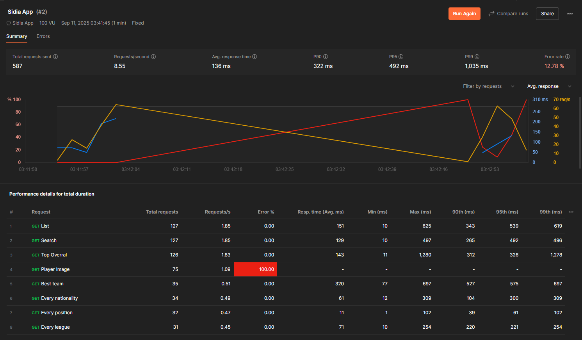

It is important to note that all requests to Player Image returned error ESOCKETTIMED OUT (100).

## 8. Technical Statement

The web application does not fully meet all the requirements, because:

* It fails to display the player picture in player’s details
* Name and team search are inaccurate
* Some Top Teams squads present duplicated players
* Some special characters when used in name and team fields to search for a player will return players when they shouldn’t
* Number of pagers adjust according to the top X players and not the number of players in Top Players, generating empty pages

Therefore, corrections are necessary before releasing the web application.

## 9.Suggestions

Here are some suggestions to improve user experience:

* In pagination, hide first|previous buttons if the user is in the first page, do the same for next|last if user is in the last page.
* In pagination, show all the listed players.
* Organize dropdown list in alphabetical order.
* When searching for players, show a “searching by:” with all filters being used.
* Some players have names that don’t use Latin characters, it would be easier to search for them if, besides the original name, a translated version were shown.